13 Ways to Make Your Dog Happy!
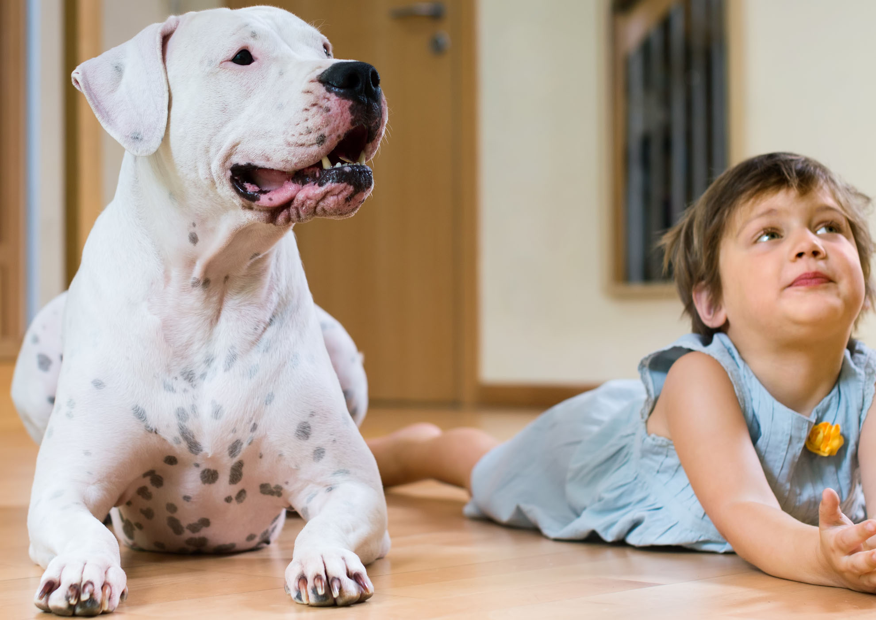
- Bring your dog inside! He will be so happy and you will have a new, true friend.
- Add a fence. Fences give freedom and make it easy for you approach your dog, since he won't be jumping on a chain. Ask fencing companies for leftovers or post to social media asking for help with labor or supplies. See unchainyourdog.org for more.
- If your dog can escape your fence:
  - Extend height by attaching mesh fencing to top of existing fence.
  - Attach bamboo fencing, which comes in 6-foot rolls, to existing fence. It’s hard to climb.
  - Install a "hot wire" to the top of your fence. You can get one at farm supply or hardware stores.
  - To stop diggers, bury chicken wire under the fence or put concrete blocks around it. You can dig a trough under the fence and fill it with concrete (along the whole fence or in "trouble spots").
- Spaying and neutering will help your dog calm down. Sterilization will NOT change your dog’s personality but provides health benefits. Contact your humane society or SpayUSA.org at 1-800-248-7729
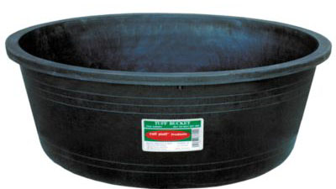
- Replace tight old collars with a new nylon one. You should be able to fit two fingers between the dog's neck and collar. If you need to add a hole, hammer a nail through the collar.
- Provide food and fresh water every day. Put a bowl in a hole the ground to keep it from tipping. Attach a bucket to a doghouse or fence with a bungee cord. Farm supply stores sell large rubber livestock bowls that are hard to tip.
- Provide good shelter in winter.
Rubber livestock bowl won’t tip
- Dogs get cold like we do. If you can’t bring your dog in, fill doghouses with hay or cedar.
- To keep cold air out, cover the door with a plastic flap, car mat, piece of carpet, or blanket.
- Doghouses should be large enough for your dog to stand up and turn around, but small enough to trap body heat.
- Doghouses can be raised a few inches on concrete blocks to keep out water
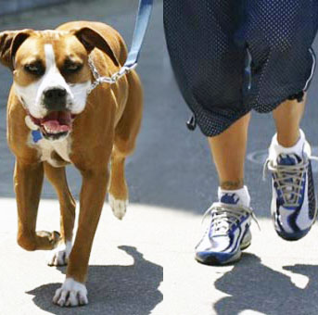
- Give toys and rawhides. A rawhide from the grocery or even knotted towel or ball provides fun!
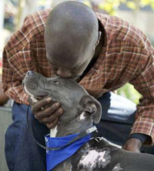
- Go on walks! Your dog will be so happy to get of the yard, and it’s great exercise for you! Leash training will take some time, but is so worth it! Harnesses that hook in front are great for large, strong dogs.
- Go to school. Obedience classes at pet stores can help your dog learn to be a good “inside” dog.
- Protect from fleas, ticks, and worms. Biting insets make life miserable. Farm supply stores sell supplies cheaply. Heartworms could kill your dog - get preventative at the vet or online (pets-megastore.com.au doesn’t require a prescription).
- Provide shade and a kiddie pool in summer. Doghouses get hot in summer! Plant trees or create shade by stretching a tarp. Dogs enjoy cooling off in a baby pool, too!
- Consider finding a new home for your dog if you can’t meet his needs. Talk to your humane society, put an ad in the paper, post to social media, or ask friends and family. If you can’t provide for your dog, finding him a new home is the kindest thing you can do.

Are Chained Dogs Good Guard Dogs?
Chaining makes dogs aggressive - not protective.
A protective dog is used to people and can tell when his family is threatened. When your dog loves you, he will want to protect you.
Leaving a dog on a chain raises an aggressive dog. Aggressive dogs don’t know the difference between friends and enemies, because they are not used to people. Aggressive dogs will attack anyone - children, a policeman, the meter reader, other dogs.
If your aggressive dog attacks someone, you could be sued. Your dog could be quarantined or put to sleep.
Every year chained dogs attack and kill children.
A chained dog can’t stop an intruder! All he can do is bark.
Do you get up and look every time your dog barks? Barking is not a good way to protect your house.
Inside dogs provide very good security.
An intruder will think twice about breaking into your home if he hears a dog on the other side of the door.
K9 police dogs are the best guard dogs, and they live inside with the family.
K9 police officers are with their dogs 24/7. Police dogs become a loved part of the police officer’s family. They are not chained in the yard. They are treated with kindness. This kindness makes the dog want to protect the officer.
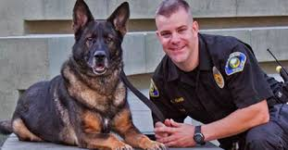
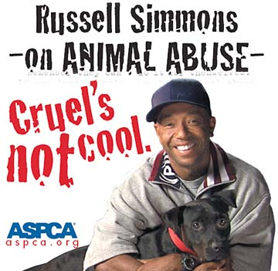
If you need a burglar alarm, consider an electronic one.
Installation is usually free, and the monthly fee costs about the same amount as caring for a dog.

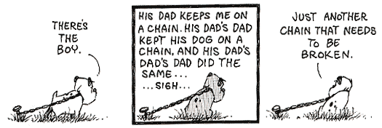
Mutts, by Patrick McDonnell

Dog Care and Behavior
Dogs who have been chained can make great house dogs, but will need extra training. Your "outside" dog will be excited when first coming in. Don’t give up! It will take some time for your dog to calm down and become an indoor family member.
    - Teach him how to walk outside on a leash.
    - Bring him inside on the leash and walk him through the house. Give him a few treats.
    - Let him hang out in one room only, keeping quiet and calm. Keep other pets and people away.
    - Slowly introduce him to other rooms and people.
    - Take him outside OFTEN for bathroom breaks (read more below).

Behavior Tips
- Barking: Chained dogs bark out of frustration and loneliness. Just getting your dog off the chain will reduce barking. Try teaching the word "quiet." When your dog barks, after two or three woofs, praise her for sounding the alarm. Then say "quiet" and give a treat. Most dogs stop barking because they can't eat and bark at the same time. During this quiet time praise her, "Good girl, quiet." Each time she is told "quiet" and succeeds, give a treat.
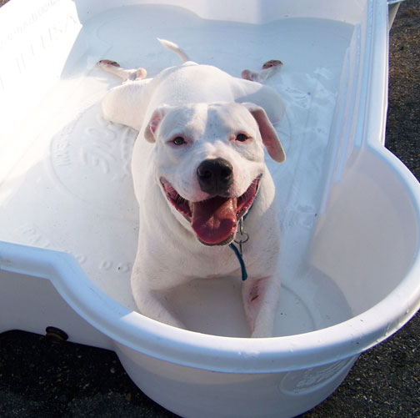
Chance is happy to be free
from his chain!
- Baths: You will enjoy spending time with your dog more if she's nice and clean! The easiest way to bathe a dog outside is to tether her to a fence or tree so she can't escape. The Rapid Bath system is great - it fits to your hose so the soap and water come out together. When you bathe your dog, throw the collar in the wash to keep it soft and clean.
- Begging: No one should feed the dog from the table. Don't allow guests to break this rule. Feed him before your meal.
- Chewing/Mouthing: Dogs need to get used to the feel of human skin, but also need to learn how to be gentle. When the dog nips you, yank back and say, "Yip". Not the way a person would say it, but the way a puppy would say it...high-pitched and loud! She will think she's hurting you.
If this doesn’t work, try pulling your hand away and turning totally away from the dog for 5 seconds. Do this every time she chews. She will learn that she gets ignored for chewing on you. Replace whatever she was chewing on with a toy. A spritz in the face with a water spray bottle will help.
- Destroying Things: Never leave an untrained dog alone in the house. A crate is best. Privileges are earned and your new dog must be trained before having total freedom. Keep chew toys and rawhides handy. A spray bottle with water is a great way to stop bad behavior. When he starts to chew on the furniture or act up, spritz him in the face with water. Dogs hate this! After a few times you should be able to just hold up the bottle to stop the behavior!
- Digging: If your dog is digging from boredom, walks and coming inside will redirect his energy. If digging to escape, bury chicken wire or add concrete blocks around the fence. Dedicated diggers may need a "digging zone" with loose soil or sand. Bury treats to encourage digging in that area.
- Jumping: When your dog jumps on you, quickly bring your knee up and turn away. Don’t say anything or look her in the eye. Your dog wants your attention and will take negative attention as well as positive attention.
Only give your dog attention when all four feet are on the floor.
Leaving and returning should be low-key. If you greet your dog loudly and full of energy, your dog will be excited, too. Stay calm and encourage calm behavior.
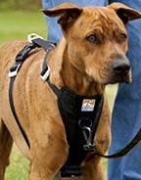
- Leash Training: Start with short walks and be patient! For large strong dogs, an "easy walk" or harness that hooks in front is a great solution. Prong and vibrating collars may be good tools, too. Pet stores can fit your dog for harnesses and help.
Try tiring the dog out before walking – throw a ball or play chase. This will get some of his energy out.
The goal is for your dog walk beside you with a loose leash and be focused on you. If you let him pull to the end of the leash, you will create a pulling machine! Get a short non-retractable leash and bring training treats (or hot dog cut into small bites).
Each time he pulls forward, stop and pull him back with the word "heel". When he walks beside you, give a treat and praise. You can stop during your walk and have him "sit" for a treat to encourage being by your side. Only move forward when he's not pulling.
- Introducing Two Dogs: Leave your dog home when getting the new dog. Introduce them on neutral territory, such as on the sidewalk, then take them on a walk. Next, let them in the yard together on leashes. Then go to a large room in the house where they can keep some distance.
Feed them separately for a few days and don't leave treats or toys out to fight over. Don't leave them in the same room until they are getting along.
Dogs will have to work out between them which is alpha or "the boss", so some fussing is natural. Keep that water spray bottle handy and spritz their faces if they get aggressive, then praise when they act nice!
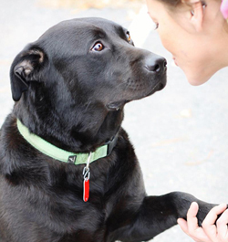
Shawnee learns to sit after being freed from her chain.

- Sitting: Hold a treat in front of her nose, then above her head until she sits back to follow the treat in your hand. Repeat the word sit several times, then immediately give praise and the treat. Most dogs quickly learn the combination of the word "sit" and a hand motion above their head.
For more info, Google terms such as stop dog barking, dog pulls on leash, etc. Two good sites: cesarsway.com and aspca.org/pet-care

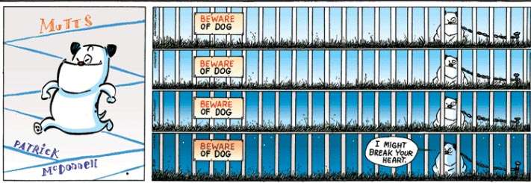
Housetraining Tips
The Golden Rule of Housetraining is...
Never let an un-housetrained dog out of your sight while the dog is inside! Every time a dog relieves himself inside, it teaches him it’s OK. An un-housetrained dog should be either:
(1) Inside, with you watching him
(2) Outside
(3) In a crate or small confined area
If you follow these rules, your dog should be trained in a week or two.
- The best method is crate training. Get a pet carrier or cage big enough for your dog to stand up, turn around, and lie down in. This will be the dog's “den”.
- Dogs are clean animals. Even puppies will try their best not to go inside their crate.
- On the dog’s first day home, let him wander in and out of the crate. Put a towel and some treats in it. Put the crate close to where the family hangs out, so your dog will feel like part of the family.
- Young puppies must go out many times a day, 30 minutes after eating or drinking. Older dogs need to go out four or more times daily.
- Take the dog to the SAME spot outdoors. The smell will remind him why he's there.
- When puppy relieves himself outside, PRAISE him, "Good Dog!!” and give him a treat. Praise is the key to housetraining! Your dog will learn that going outside means treats, and will be eager to go out.
- If you're inside and notice your dog starting to sniff and circle, grab him and take him out. If you catch him in “mid-stream”, startle pup with a noise and take him out.
- What if you notice a mess on the floor but didn’t see your dog do it? Clean up the mess without fussing at your dog. Dogs live in the moment and won’t understand you are punishing him for something he did in the past. Rubbing your dogs’ nose in the mess or hitting him with a newspaper won’t work.
- Use a cleaner that kills smells and bacteria, such as Simple Green, Nature’s Miracle, or vinegar and water. If you don’t clean the spot very well, the smell might make him go there again.
- At bedtime, take your dog outside then lock him in his crate for the night. He'll make an effort not to foul his bed. Then take him out first thing in the morning. Some young puppies may not have the muscle control to hold it all night and will have to go out during the night.
- Don’t feed or water your dog for 4 hours before bedtime.
- Dogs can be left in a crate 4-6 hours. Dogs should not be left in a crate more than 8 hours. If you can’t come home during the day, consider leaving the dog outside.
- Tips: Hang a jingle bell on the door and jingle it when you take your dog out. He will learn to ring the bell when he needs to go out.
Install a dog door. Dogs quickly learn to come and go on their own.
Mutts, by Patrick McDonnell
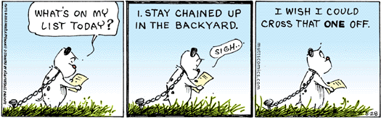

How to Build a Mesh Fence
You can buy all materials at farm supply stores such as Tractor Supply or stores such as Home Depot.
Watch fence-building videos at UnchainYourDog.org/fences.htm or beyondfences.org.
Use social media to request help! Fencing companies may donate materials, too.
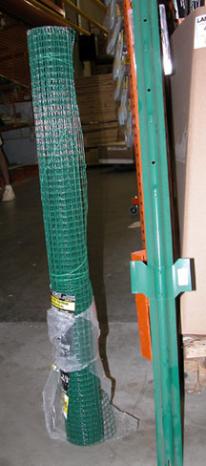
Mesh cloth and T-post

Supplies

- Posts. Choose metal T-posts or wooden posts.. Place posts 6-8 feet apart.
- Mesh or hardware cloth comes in rolls, in different strengths. Your fence will be stronger if you get a strong mesh (like the welded wire below.)
- Baling wire or metal ties to attach the mesh to the posts. Baling wire comes in a roll and can be cut into pieces with wire cutters. A heavy duty staple gun can be used to attach mesh fencing to wooden posts.
- Concrete if setting wooden posts. One 40-lb bag of concrete will set two posts.
- Shovel or post-hole digger if setting posts in concrete.
- Gate (if you can’t walk into the fenced area from your door). You can buy pre-made chain link gates or make one out of wood. Gates must be set in concrete to be sturdy.
Welded wire

Instructions
- Decide where you want your fence to go. Mark with spray paint or push sticks into the ground and tie string between sticks.
- Lay posts next to your lines, where you plan to stand them up.
  - The closer you place the posts to each other, the stronger the fence will be. About 8 feet apart is good.
- Pound metal T-posts into the ground with a hammer or post driver. Set wooden posts with concrete.
  - T-posts should be put in the ground until the "V" is covered. Wooden posts should have about a foot underground.
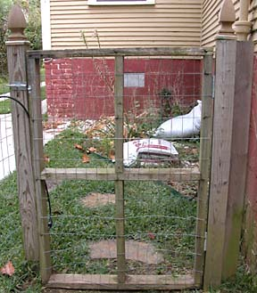
Wood gate with welded wire stapled to it

- Attach mesh to T-posts with wire ties or baling wire. Attach mesh at the top, middle, and bottom of the post.
  - Stretch the fencing as tightly as possible against the posts. One person should pull the mesh very tightly against the post while someone else attaches the mesh to the post
  - Be sure the mesh is all the way to the ground.
- Carefully measure where the gate posts will go to ensure the gate will swing and latch correctly. Set gate posts in concrete to ensure they will be sturdy.

How to Set a Post
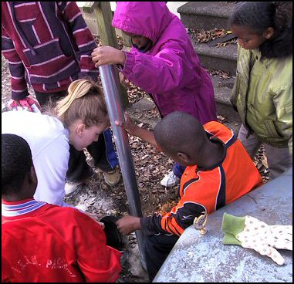
Materials:
- Strong wooden post
- 40 lb. bag concrete mix per post. You can use quick-set.
- Stick or dowel
- Water from a bucket or hose
- Shovel or post-hole digger
Instructions:
- Dig a hole for the post. The post needs to be 1.5 to 2 feet underground.
- Put a few rocks in the bottom of the hole, then set the post in the hole. Have someone to hold the post in the center of the hole.
- Pour 1/3 of the concrete mix in the hole around the post. Pour about 1/2 gallon of water into the hole and stir the concrete with the stick.
- Keep adding concrete mix and stirring water until the hole is filled.
- Cover concrete with dirt. Pile dirt or rocks around the bottom of the post to keep it in place while concrete sets.
With regular concrete, the post should be set in 24 hours. With quick-set, it will be ready in an hour.
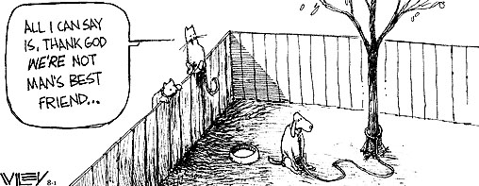

Make Your Fence Higher
Get a roll of mesh fencing, also called hardware cloth.
Mesh cloth comes in different strengths. Some is thin and easy to bend (like chicken wire) and some is thick and sturdy. Buy some strong enough to stay upright at the top of your fence but light enough to bend in place.
Roll out the fencing and attach it to the top of your fence. Attach it with wire ties or pieces of baling wire. If you can’t attach wire to the top of your fence, install tall T-posts every 6 feet and attach the mesh across the tops of the T-posts.
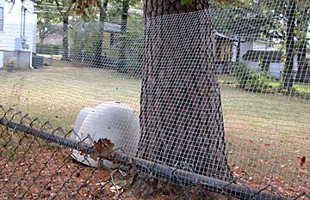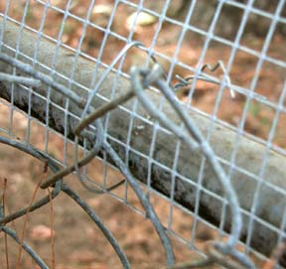
This owner had a dog who always jumped the fence. After extending the fence height, the dog couldn’t escape!
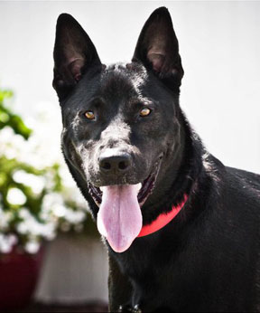
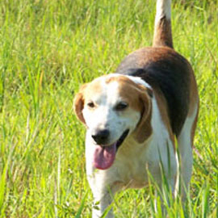
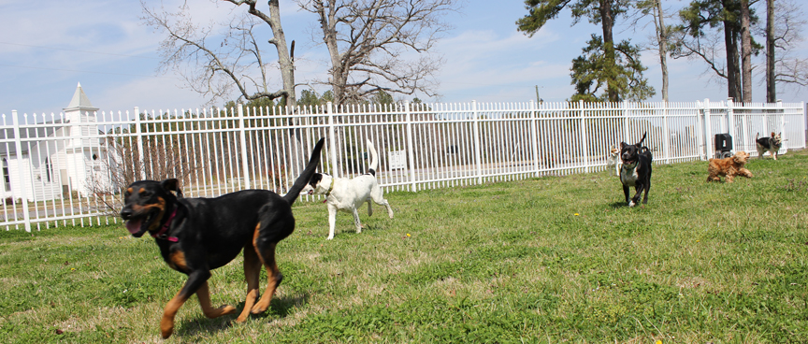
Visit UnchainYourDog.org, DogsDeserveBetter.org and UnchainedMelodies.org to learn more about how to improve the lives of chained dogs.
Thank you for caring!
These dogs were all rescued from chains

