Will You Adopt Me?

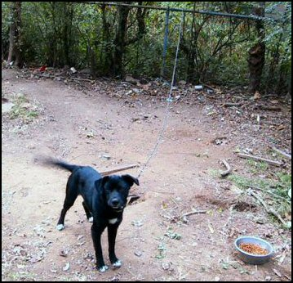
Before my rescue

I lived on a chain before my owners
abandoned me.
I am…

Two years
40 pounds
Spayed
Vaccinated
Housebroken
Healthy

I am very sweet and love to play with kids, cats, and other dogs.
Any other info to share??

Call Tommy Smith
888-8888 tsmith@email.com

868-7375
pvahptb@yahoo.com
888-8888
email@email.com
888-8888
email@email.com
888-8888
email@email.com
888-8888
email@email.com
888-8888
email@email.com
888-8888
email@email.com
888-8888
email@email.com
888-8888
email@email.com
888-8888
email@email.com
888-8888
email@email.com
888-8888
email@email.com
888-8888
email@email.com
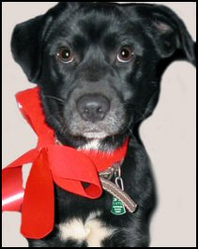
Look at me now!

